

JAVA PROJECT
ON
BMI CALCULATION
Submitted by:-
- HEER VANKAWALA - RA1511008010371
- SUKRITI TIWARI - RA1511008010407
- MEGHANA POLISETTY - RA1511008010361
ABSTRACT
This is a JAVA SWING Application project created using NetBeans IDE 8.2 on BMI calculator, which calculates the BODY MASS INDEX of a person by taking his/her height and weight on the GUI interface.
The formula for calculating BMI is:
BMI= weight/(height)^2
The body mass index (BMI) or Quetelet index is a value derived from the mass (weight) and height of an individual. The BMI is defined as the body mass divided by the square of the body height, and is universally expressed in units of kg/m^2, resulting from mass in kilograms and height in metres.
The BMI may also be determined using a table or chart which displays BMI as a function of mass and height using contour lines or colours for different BMI categories, and which may use other units of measurement (converted to metric units for the calculation).
The BMI is an attempt to quantify the amount of tissue mass (muscle, fat, and bone) in an individual, and then categorize that person as underweight, normal weight, overweight, or obese based on that value. However, there is some debate about where on the BMI scale the dividing lines between categories should be placed. Commonly accepted BMI ranges are underweight: under 18.5 kg/m^2, normal weight: 18.5 to 24.9, overweight: 25 to 29.9, obese: over 30. People of Asian descent have different associations between BMI, percentage of body fat, and health risks than those of European descent, with a higher risk of type 2 diabetes and cardiovascular disease at BMIs lower than the WHO cut-off point for overweight, 25 kg/m^2, although the cutoff for observed risk varies among different Asian populations.

CODE
public class Calculating_BMI extends javax.swing.JFrame {
public Calculating_BMI() {
initComponents();
}
@SuppressWarnings("unchecked")
private void initComponents() {
jLabel1 = new javax.swing.JLabel();
jLabel2 = new javax.swing.JLabel();
jLabel3 = new javax.swing.JLabel();
jTextField1 = new javax.swing.JTextField();
jTextField2 = new javax.swing.JTextField();
jLabel4 = new javax.swing.JLabel();
jLabel5 = new javax.swing.JLabel();
jButton1 = new javax.swing.JButton();
jTextField3 = new javax.swing.JTextField();
jTextField4 = new javax.swing.JTextField();
setDefaultCloseOperation(javax.swing.WindowConstants.EXIT_ON_CLOSE);
jLabel1.setFont(new java.awt.Font("Modern No. 20", 1, 36)); // NOI18N
jLabel1.setForeground(new java.awt.Color(0, 0, 255));
jLabel1.setText("CALCULATE YOUR BMI");
jLabel2.setFont(new java.awt.Font("Lucida Calligraphy", 0, 18)); // NOI18N
jLabel2.setText("Enter your weight");
jLabel3.setFont(new java.awt.Font("Lucida Calligraphy", 0, 18)); // NOI18N
jLabel3.setText("Enter your height");
jLabel4.setFont(new java.awt.Font("Lucida Calligraphy", 0, 18)); // NOI18N
jLabel4.setText("kg");
jLabel5.setFont(new java.awt.Font("Lucida Calligraphy", 0, 18)); // NOI18N
jLabel5.setText("cm");
jButton1.setBackground(new java.awt.Color(0, 153, 153));
jButton1.setFont(new java.awt.Font("Segoe Print", 1, 16)); // NOI18N
jButton1.setText("Calculate");
jButton1.addActionListener(new java.awt.event.ActionListener() {
public void actionPerformed(java.awt.event.ActionEvent evt) {
jButton1ActionPerformed(evt);
}
});
jTextField3.setFont(new java.awt.Font("Georgia", 0, 14)); // NOI18N
jTextField4.setFont(new java.awt.Font("Georgia", 0, 14)); // NOI18N
javax.swing.GroupLayout layout = new javax.swing.GroupLayout(getContentPane());
getContentPane().setLayout(layout);
layout.setHorizontalGroup(
layout.createParallelGroup(javax.swing.GroupLayout.Alignment.LEADING)
.addGroup(layout.createSequentialGroup()
.addGroup(layout.createParallelGroup(javax.swing.GroupLayout.Alignment.LEADING)
.addGroup(layout.createSequentialGroup()
.addGap(134, 134, 134)
.addGroup(layout.createParallelGroup(javax.swing.GroupLayout.Alignment.LEADING)
.addComponent(jLabel1)
.addGroup(layout.createParallelGroup(javax.swing.GroupLayout.Alignment.TRAILING)
.addGroup(javax.swing.GroupLayout.Alignment.LEADING, layout.createSequentialGroup()
.addGap(40, 40, 40)
.addComponent(jLabel2)
.addGap(18, 18, 18)
.addComponent(jTextField1, javax.swing.GroupLayout.PREFERRED_SIZE, 100, javax.swing.GroupLayout.PREFERRED_SIZE)
.addGap(18, 18, 18)
.addComponent(jLabel4))
.addGroup(layout.createSequentialGroup()
.addGap(39, 39, 39)
.addGroup(layout.createParallelGroup(javax.swing.GroupLayout.Alignment.TRAILING)
.addGroup(layout.createSequentialGroup()
.addComponent(jLabel3)
.addGap(18, 18, 18)
.addComponent(jTextField2, javax.swing.GroupLayout.PREFERRED_SIZE, 100, javax.swing.GroupLayout.PREFERRED_SIZE)
.addGap(18, 18, 18)
.addComponent(jLabel5))
.addGroup(layout.createSequentialGroup()
.addComponent(jTextField3, javax.swing.GroupLayout.PREFERRED_SIZE, 69, javax.swing.GroupLayout.PREFERRED_SIZE)
.addGap(44, 44, 44)
.addComponent(jTextField4, javax.swing.GroupLayout.PREFERRED_SIZE, 166, javax.swing.GroupLayout.PREFERRED_SIZE)
.addGap(28, 28, 28)))))))
.addGroup(layout.createSequentialGroup()
.addGap(305, 305, 305)
.addComponent(jButton1)))
.addContainerGap(145, Short.MAX_VALUE))
);
layout.setVerticalGroup(
layout.createParallelGroup(javax.swing.GroupLayout.Alignment.LEADING)
.addGroup(layout.createSequentialGroup()
.addGap(35, 35, 35)
.addComponent(jLabel1)
.addGap(82, 82, 82)
.addGroup(layout.createParallelGroup(javax.swing.GroupLayout.Alignment.BASELINE)
.addComponent(jLabel2)
.addComponent(jTextField1, javax.swing.GroupLayout.PREFERRED_SIZE, 25, javax.swing.GroupLayout.PREFERRED_SIZE)
.addComponent(jLabel4))
.addGap(28, 28, 28)
.addGroup(layout.createParallelGroup(javax.swing.GroupLayout.Alignment.BASELINE)
.addComponent(jLabel3)
.addComponent(jTextField2, javax.swing.GroupLayout.PREFERRED_SIZE, 25, javax.swing.GroupLayout.PREFERRED_SIZE)
.addComponent(jLabel5))
.addGap(34, 34, 34)
.addComponent(jButton1)
.addPreferredGap(javax.swing.LayoutStyle.ComponentPlacement.RELATED, 39, Short.MAX_VALUE)
.addGroup(layout.createParallelGroup(javax.swing.GroupLayout.Alignment.BASELINE)
.addComponent(jTextField3, javax.swing.GroupLayout.PREFERRED_SIZE, 30, javax.swing.GroupLayout.PREFERRED_SIZE)
.addComponent(jTextField4, javax.swing.GroupLayout.PREFERRED_SIZE, 30, javax.swing.GroupLayout.PREFERRED_SIZE))
.addGap(103, 103, 103))
);
pack();
}
private void jButton1ActionPerformed(java.awt.event.ActionEvent evt) {
String s1=jTextField1.getText();
String s2=jTextField2.getText();
float w=(float)(Integer.parseInt(s1));
float h=(float)(Integer.parseInt(s2));
float hm=h/100;
float bmi=(float)(Math.round((w/(hm*hm))*10.0)/10.0);
jTextField3.setText(String.valueOf(bmi));
if(bmi<18.5)
jTextField4.setText("Underweight");
else if(bmi>=18.5 && bmi<=24.9)
jTextField4.setText("Normal");
else if(bmi>=25 && bmi<=29.9)
jTextField4.setText("Overweight");
else if(bmi>=30)
jTextField4.setText("Obese");
}
public static void main(String args[]) {
try {
for (javax.swing.UIManager.LookAndFeelInfo info : javax.swing.UIManager.getInstalledLookAndFeels()) {
if ("Nimbus".equals(info.getName())) {
javax.swing.UIManager.setLookAndFeel(info.getClassName());
break;
}
}
} catch (ClassNotFoundException ex) {
java.util.logging.Logger.getLogger(Calculating_BMI.class.getName()).log(java.util.logging.Level.SEVERE, null, ex);
} catch (InstantiationException ex) {
java.util.logging.Logger.getLogger(Calculating_BMI.class.getName()).log(java.util.logging.Level.SEVERE, null, ex);
} catch (IllegalAccessException ex) {
java.util.logging.Logger.getLogger(Calculating_BMI.class.getName()).log(java.util.logging.Level.SEVERE, null, ex);
} catch (javax.swing.UnsupportedLookAndFeelException ex) {
java.util.logging.Logger.getLogger(Calculating_BMI.class.getName()).log(java.util.logging.Level.SEVERE, null, ex);
}
java.awt.EventQueue.invokeLater(new Runnable() {
public void run() {
new Calculating_BMI().setVisible(true);
}
});
}
// Variables declaration - do not modify
private javax.swing.JButton jButton1;
private javax.swing.JLabel jLabel1;
private javax.swing.JLabel jLabel2;
private javax.swing.JLabel jLabel3;
private javax.swing.JLabel jLabel4;
private javax.swing.JLabel jLabel5;
private javax.swing.JTextField jTextField1;
private javax.swing.JTextField jTextField2;
private javax.swing.JTextField jTextField3;
private javax.swing.JTextField jTextField4;
// End of variables declaration
}

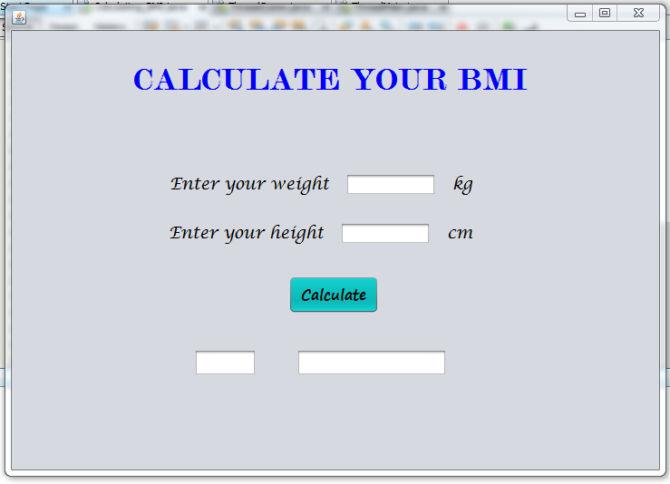
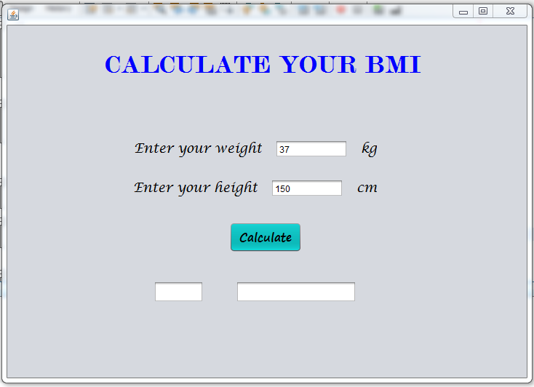
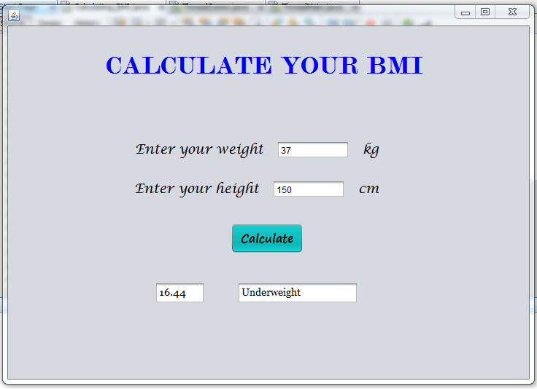
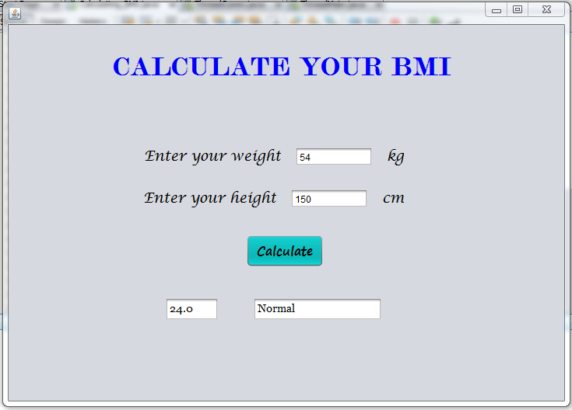
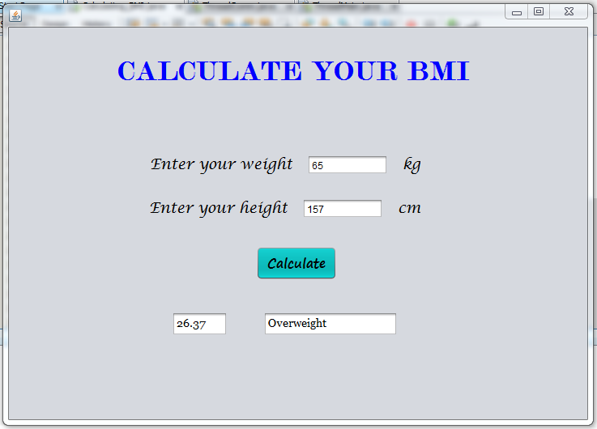
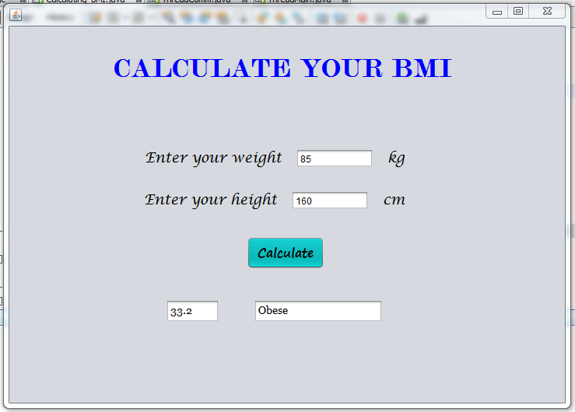
CONCLUSION
This BMI Calculator has been made in NetBeans IDE 8.2 using the concept of Swing Application. I have used various tools of JFrame like label, textfield, button, etc. to make this BMI calculator. The font and colour of texts have also been implemented.
With the help of this BMI calculator, one can know his/her body mass index by simply entering his/her weight in kg and height in cm. The calculator then tells you whether you are underweight, normal, overweight or obese. Thus, with this calculator one can constantly check his/her BMI and maintain it in the normal category or try to fit into the normal category by weight loss (if you are overweight) or mass gain (if you are underweight).
The BMI calculator is working well and seeks the better of all.

